**LAB 2 (remaining tasks)**

**Q1) 3) Write 2 C program one prints “I love Operating System” and other prints “I love Linux”. Compile and Run both programs and print the output to two different files. After then combine both the files in one new file using a single command.**

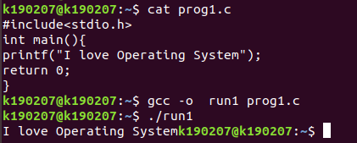

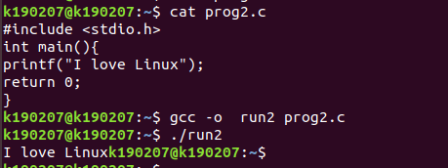

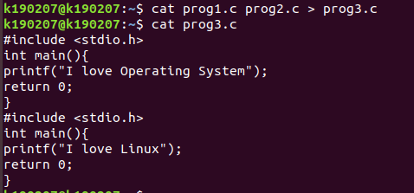

**5) Perform the following**

**a. List the files in the directory "/bin" that end in "sh".**



**b. On one line, use the "cd" command to first go to your home directory then to the "<rollnumber>" subdirectory. [Ans: cd /home; cd <rollnumber>]**



**c. What command lists the files in the current directory that begin with upper**

**case letters?**

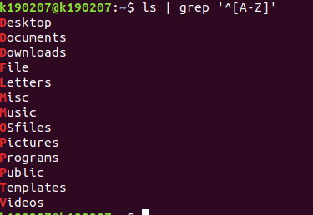

**d. If they do not already exist, create three new directories "Letters", "Programs", and "Misc" using a single command**



**e. Copy all files in the current directory whose names contain the character string "let" into the subdirectory "Letters".**



**f. Copy all files in the current directory whose names end in ".c" or ".h" into the**

**subdirectory "Programs".**



**g. Copy all files in the current directory whose names contain the character**

**strings "notes" or "misc" into the subdirectory "Misc".**



**h. Copy all files which begin with "copy.me" into the "OS" subdirectory. Move all files which begin with "move.me" into the "OS" subdirectory.**





**i. Delete all files which contain the sequence "del".**

